Randolph Fair – Jr Fair Help Sheet

2022 Beef Animal ID Help Sheet
Listing of Required and Optional Fields / Information by Animal Species
Note: Required – N/A means that you must enter something in that field, but there is no particular information we need – so you can just enter N/A.
Beef
 | Feeder Calves | Market Steer | Breeding Beef
Tag (Identifier) | Required | Required – County Tag # | Required
Animal Age | Optional | Optional | Optional
Animal Name | Optional | Optional | Optional
Animal Birthdate | Required | Required | Required
Brand | n/a | n/a | n/a
Breed | n/a | Required | n/a
Breeder Name | Required – n/a if  unknown | Required – n/a if  unknown | Required – n/a if unknown
Colors & Markings | n/a | n/a | n/a
County Raised | Optional | Required if Entering Class | Optional
RFID | Optional | Optional | Optional
Animal Gender | Required | Required | Required
Tag Color | n/a | n/a | Required
Tattoo | Optional | Optional | Optional
Files/Photos of Animal
Front of Animal | Required | Required | Required
Left Side of Animal | Required | Required | Required
Right Side of Animal | Required | Required | Required
Tag/Identifier Photo: | Required | Required – Photo of County Tag | Required
County Document | Optional | Optional | Optional
Born & Bred | n/a | Required if Entering Class | n/a

Steps  - Log in to your family account.  - Click to View the Member’s record for whom you would like to add an animal. | (Screen appearance may vary per state)  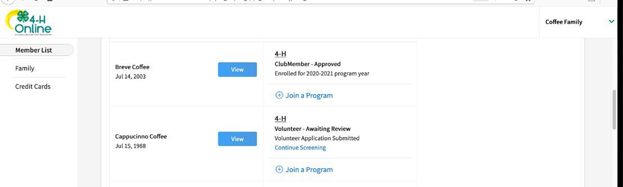
- Click Animals in the navigation pane.  - Click the blue Register Animal button. | 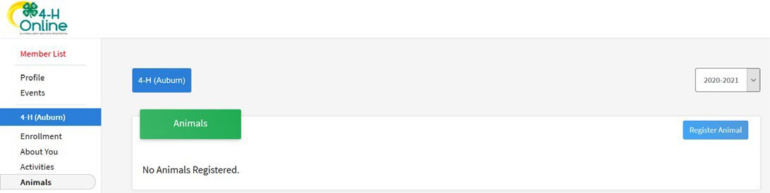
5. Click Add New Animal to start adding a new animal. | 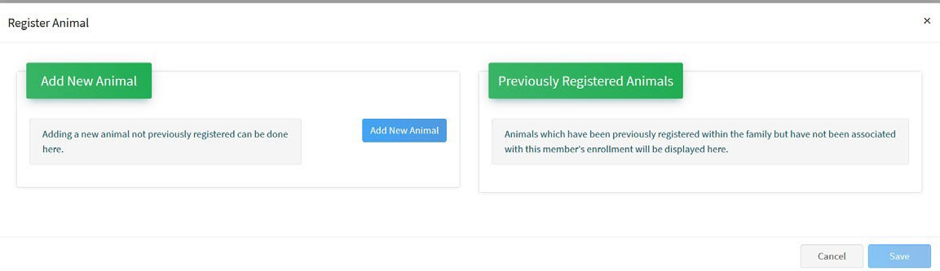

- Select the appropriate animal type from the drop-down menu.  - Enter the required Tag, Tattoo, or Animal Name as directed.  - Click Save. | 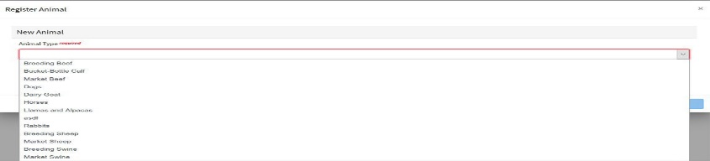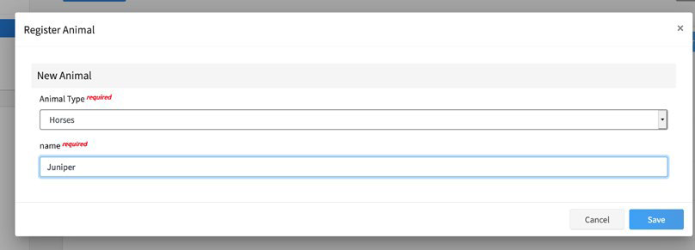
- Complete each of the required fields and optional fields as needed.  ** Please note that the fields may vary by state and animal type.  - Click the Next button at the bottom of the form. | 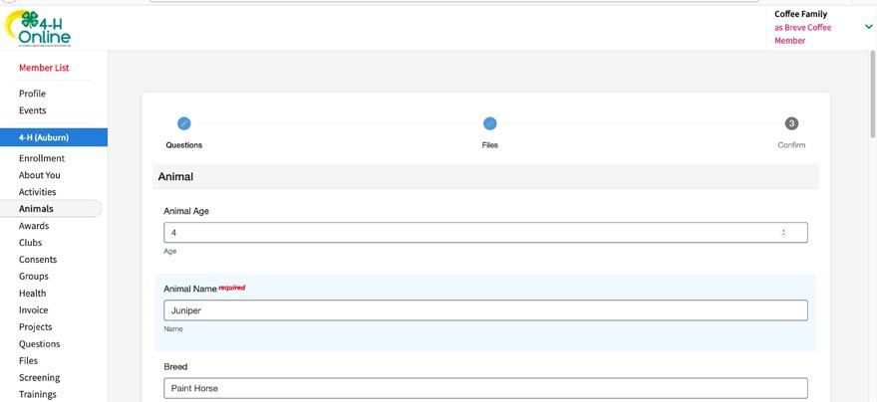
- Upload any required or optional files for this animal.  - Click the Next button | 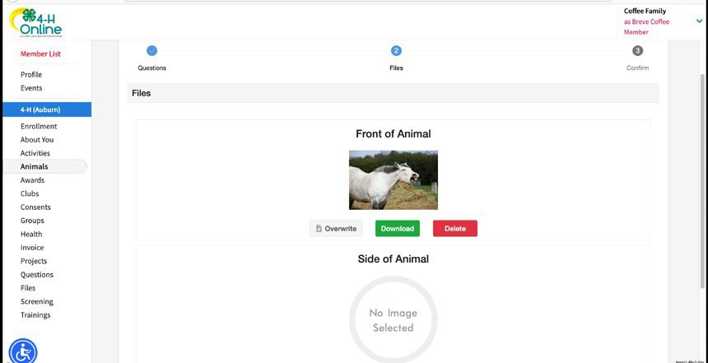
- Review the entered information. Use the Back button at the bottom of the page to return to the previous screen to make corrections.  - Once the entered information is correct and reviewed, click the Submit button. | 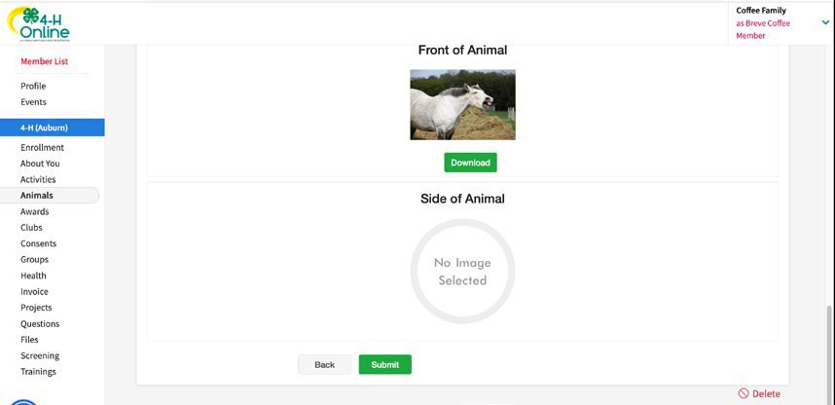
15. The animal information will display on the screen with the status, created, modified, and submitted date and time stamp (local time). | 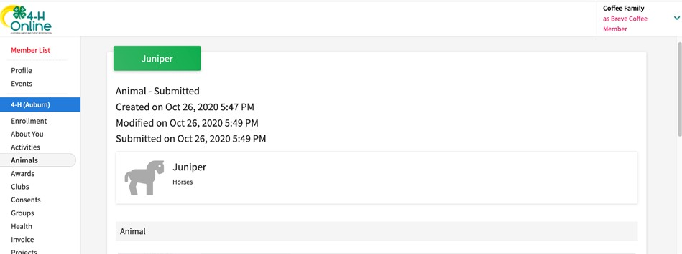
Click on the Animals tab from your account at any time to view the status for all of the animals for a member in the family.

